Domain Driven Design With Clean Architecture
https://www.youtube.com/watch?v=XEhdp2nHMVo
Why we need it
Solutions with lots of business logic will get “spaghetti” in no time
We need to concentrate on business logic
We need scalable solutions

Systems need to be built around the business logic and not keeping infrastructure in mind.

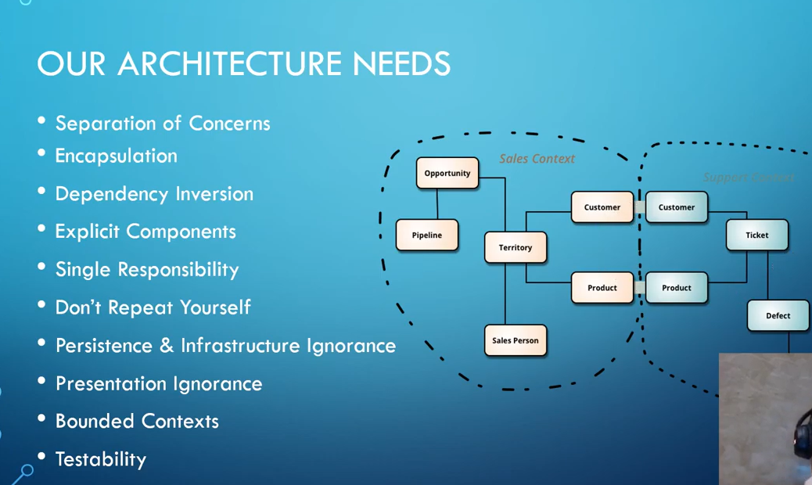

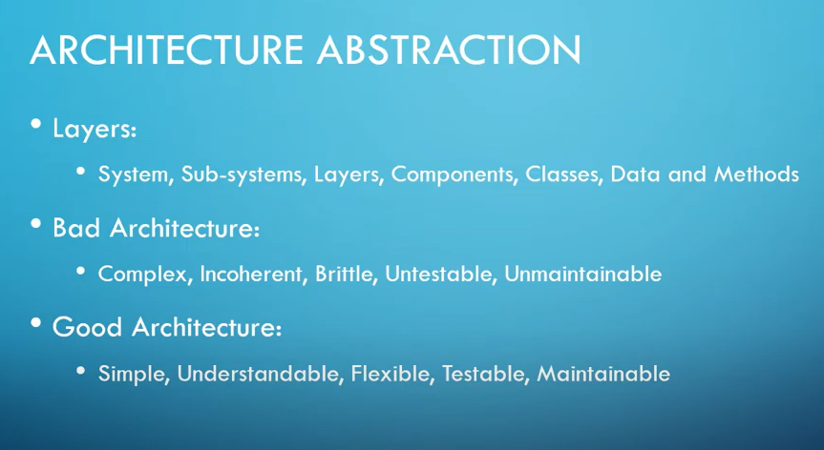

Domain Driven Design with EF Core

https://www.youtube.com/watch?v=yxtsTEhb140

Domain Driven Design is an approach to software development that centers the development on programming a domain model that has a rich understanding of the processes and rules of a domain

Domain model - A system of abstractions that describes selected aspects of a domain and can be used to solve problems related to that domain.

Bounded Contexts

A defined part of software where particular terms , definitions and rules apply in a consistent way
Clear boundaries between different parts of the system

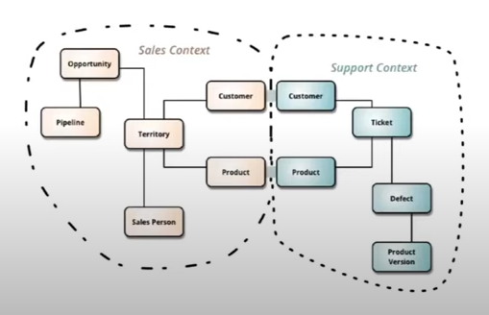

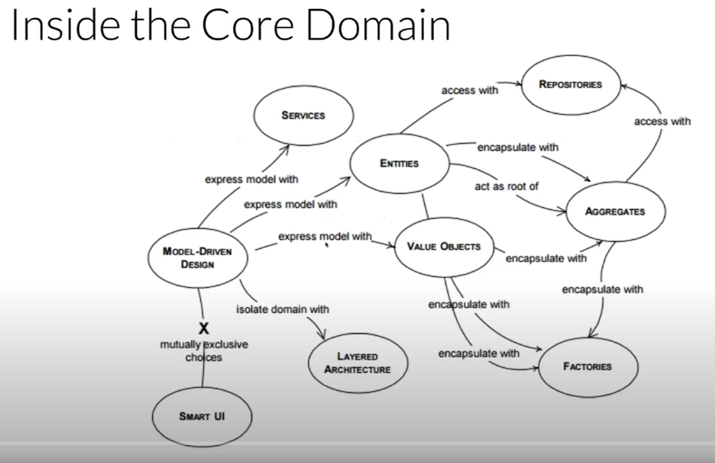

Domain Driven Design – Good parts

https://www.youtube.com/watch?v=U6CeaA-Phqo

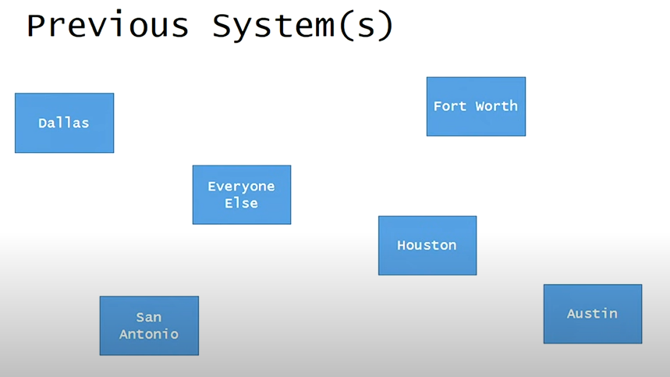

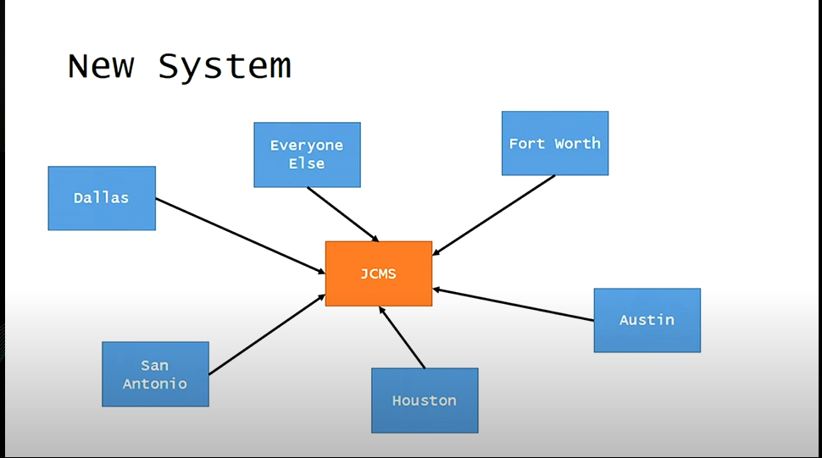

Project Goals

Increase knowledge sharing
Comprehensive system covering all aspects of juvenile process
Complete picture of juvenile process

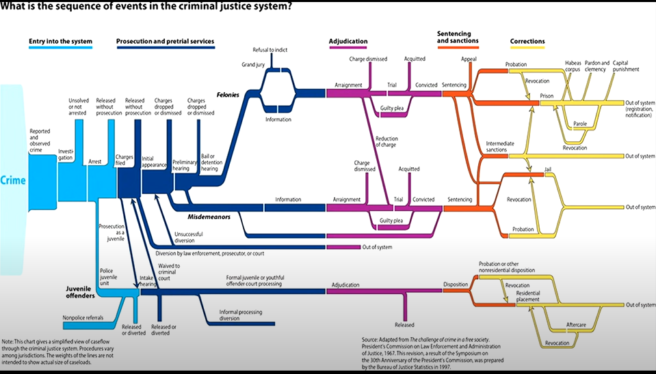

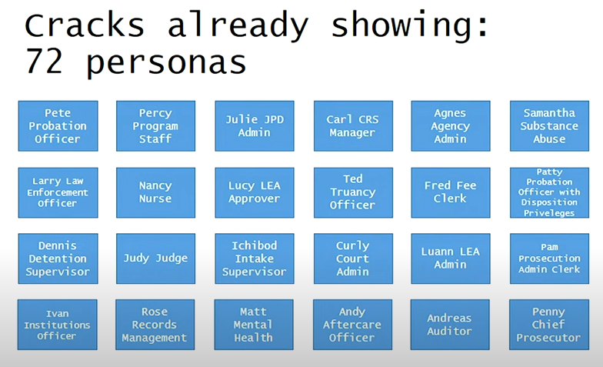

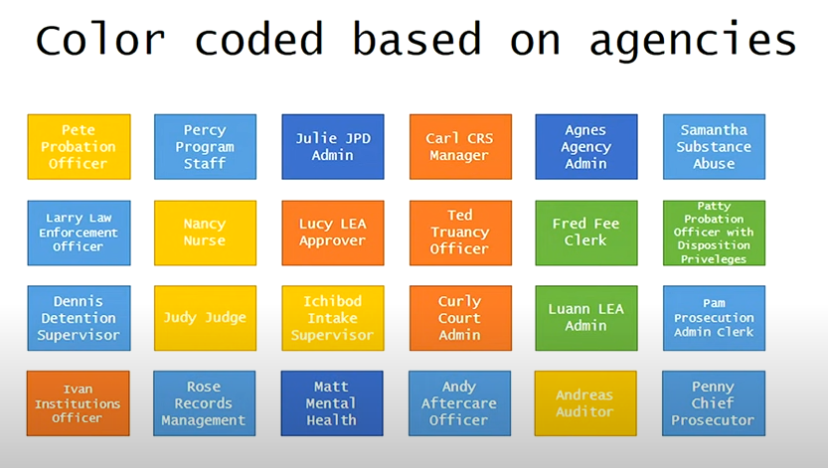

Lesson 1 : Bounded contexts are a thing
Lesson 2 : Ubiquitous language should be ubiquitous

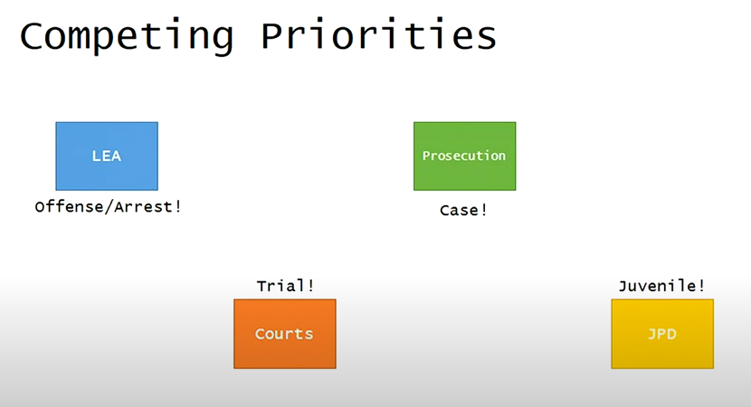

Lesson 3 : Core Domain needs consensus
Lesson 4 : Ubiquitous language needs consensus
Lesson 5 : Structural patterns least important part of DDD

